vulnerability assessment report for a live website

Future Interns Project
Cyber Security Task 1

Prepared by:
Khushi Patel

Abstract

This report presents a Vulnerability Assessment of a Live Website, conducted as part of a cybersecurity internship. The objective of this task was to identify potential security weaknesses in a real-world web application using passive and non-intrusive assessment techniques, analyze associated risks, and provide awareness and remediation recommendations. The assessment emphasizes ethical practices, scope limitations, and professional security reporting standards.

Introduction

With the increasing dependence on web applications, live websites have become common targets for cyber-attacks. Vulnerability Assessment helps organizations identify security weaknesses before attackers exploit them.
As part of this internship task, a live website was analysed to identify common vulnerabilities related to configuration, headers, and exposure of sensitive information. No active exploitation or unauthorized access was performed during this assessment.

Target Website & Scope

Target Website
- Website: testphp.vulnweb.com
- Purpose: Deliberately vulnerable web application for training

Scope of Assessment

- Passive and limited active testing
- Analysis of publicly accessible pages only
- No data modification or server exploitation
- Testing performed strictly for learning purposes

- Tools
- OWASP ZAP (Passive Scan)
- Browser Developer Tools
- Nmap
- Canva (Report design)

- Methodology

- Identified entry points of the web application
- Performed passive scanning using OWASP ZAP
- Manually tested URL parameters for input validation issues
- Analyzed HTTP headers and cookies
- Identified vulnerabilities and classified risk levels
- Documented findings with awareness and remediation guidance

Awareness & Prevention Guidelines

- Implement input validation and parameterized queries
- Sanitize user input to prevent XSS attacks
- Apply recommended HTTP security headers
- Hide unnecessary server information
- Conduct regular vulnerability assessments

Risk Classification

Risk Level | Description
Low | Informational issues with minimal impact
Medium | Vulnerabilities that require mitigation
High | Critical vulnerabilities needing immediate attention

Vulnerabilities Identified

SQL Injection (High Risk)
- Improper input validation detected in URL parameters
- Allows manipulation of backend database queries

Cross-Site Scripting (XSS) – Reflected (Medium Risk)
- User input reflected in the response without sanitization
- Can lead to session hijacking or data theft

Missing Security Headers (Medium Risk)
- Headers such as X-Frame-Options and Content-Security-Policy not implemented
- Increases risk of clickjacking and content injection

Information Disclosure (Low Risk)
- Server and application details exposed via HTTP headers
- Helps attackers during reconnaissance

Proof of work

- This scan reveals the running services and versions on the target system. The web server is using nginx/1.19.0, which may contain known vulnerabilities if not properly patched
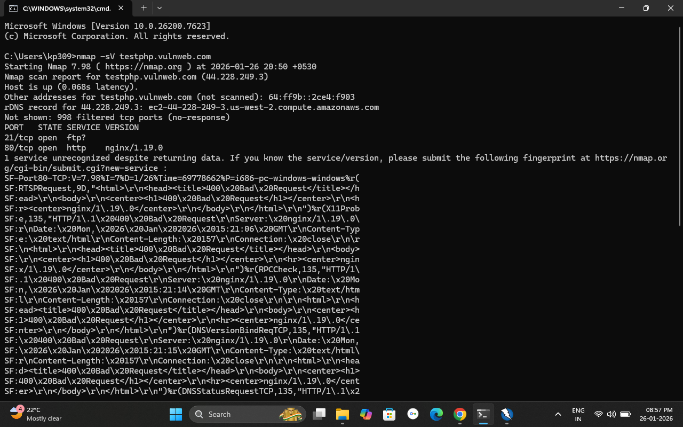

- This image shows the Nmap scan results, which identify open ports on the target server. Port 21 (FTP) and Port 80 (HTTP) are open, indicating exposed services that could be targeted by attackers.

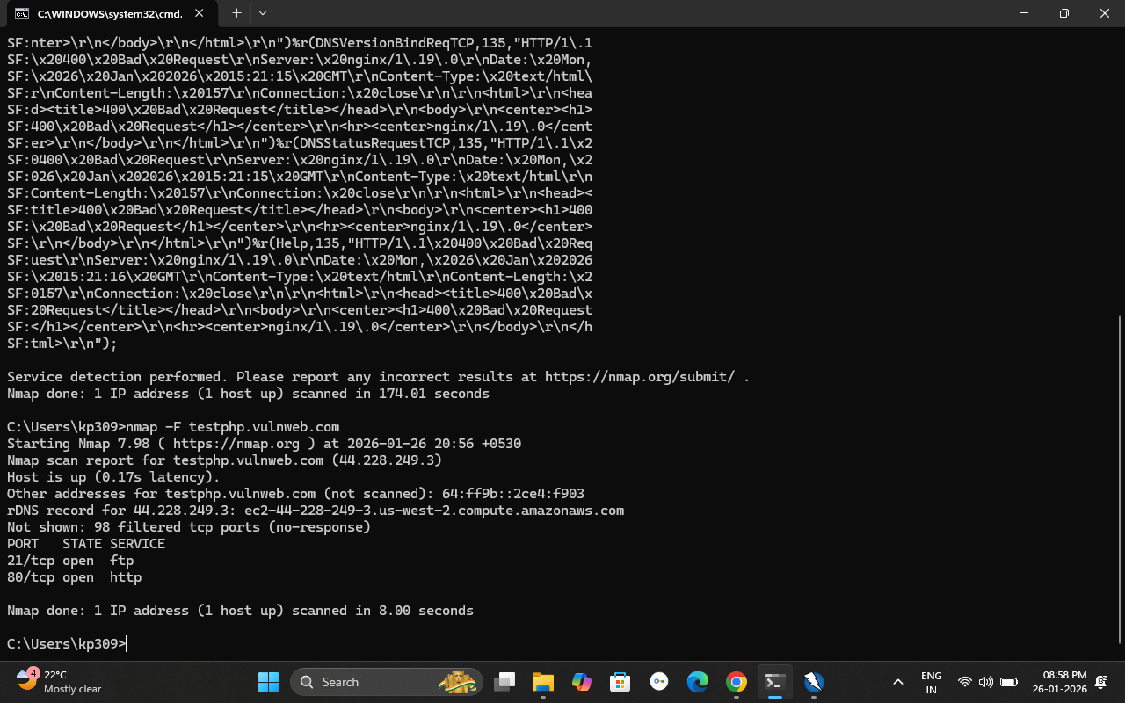

- This screenshot shows the OWASP ZAP HUD interface used for manual security testing. It helps visualize detected vulnerabilities while browsing the application.

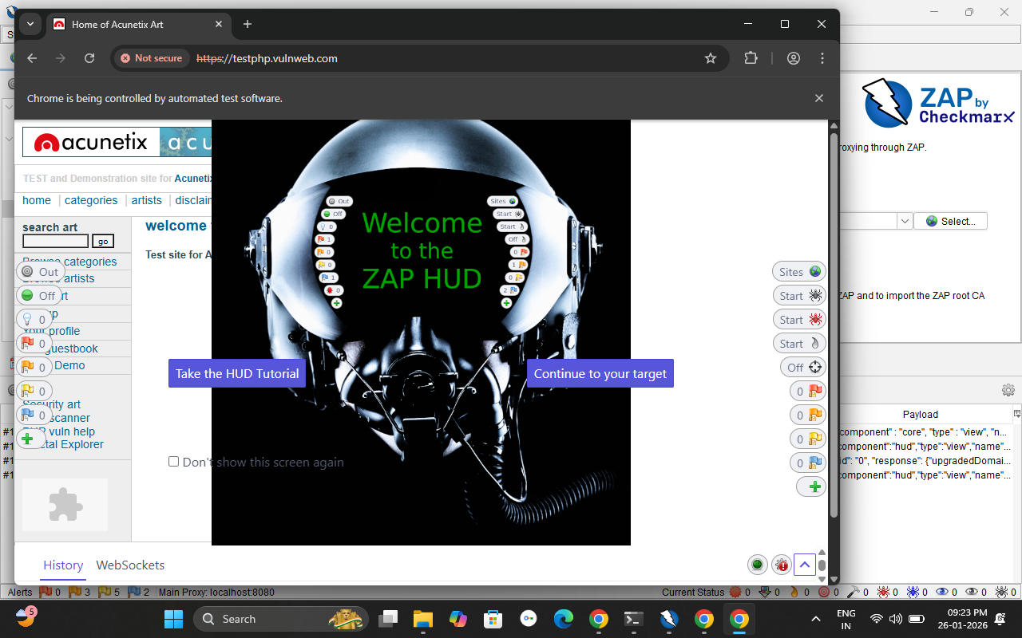

- This evidence shows a charset mismatch between the HTTP response header and the HTML meta tag, which may lead to improper content interpretation by browsers.

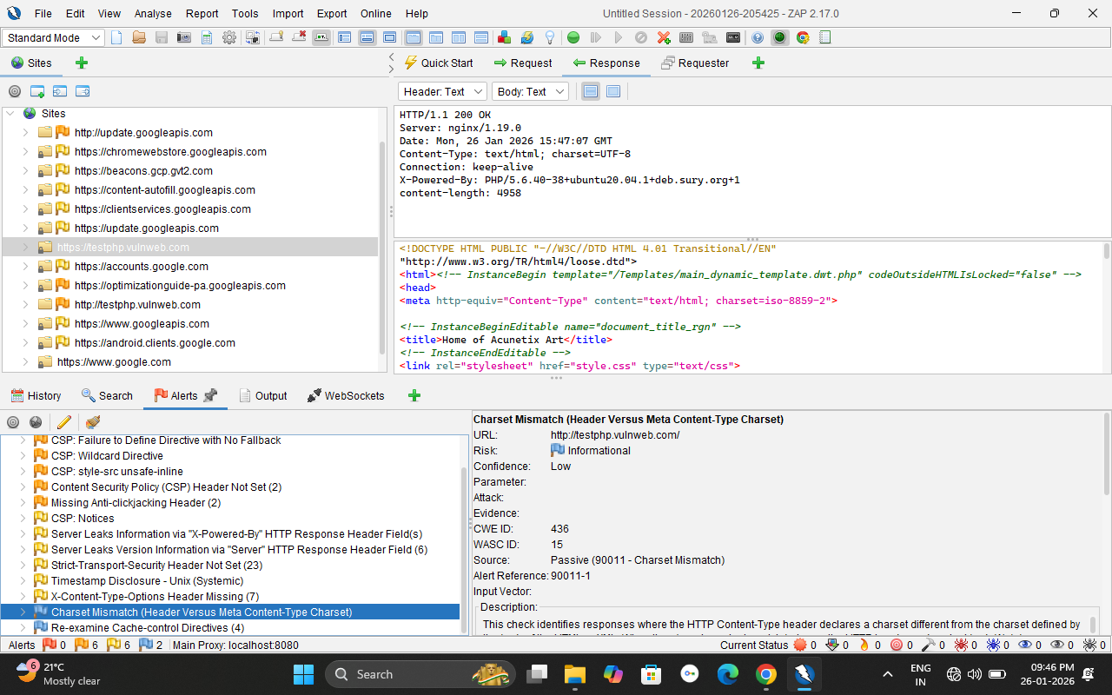

- This image indicates that no Anti-CSRF token was found in the form submission, making the application vulnerable to Cross-Site Request Forgery (CSRF) attacks.

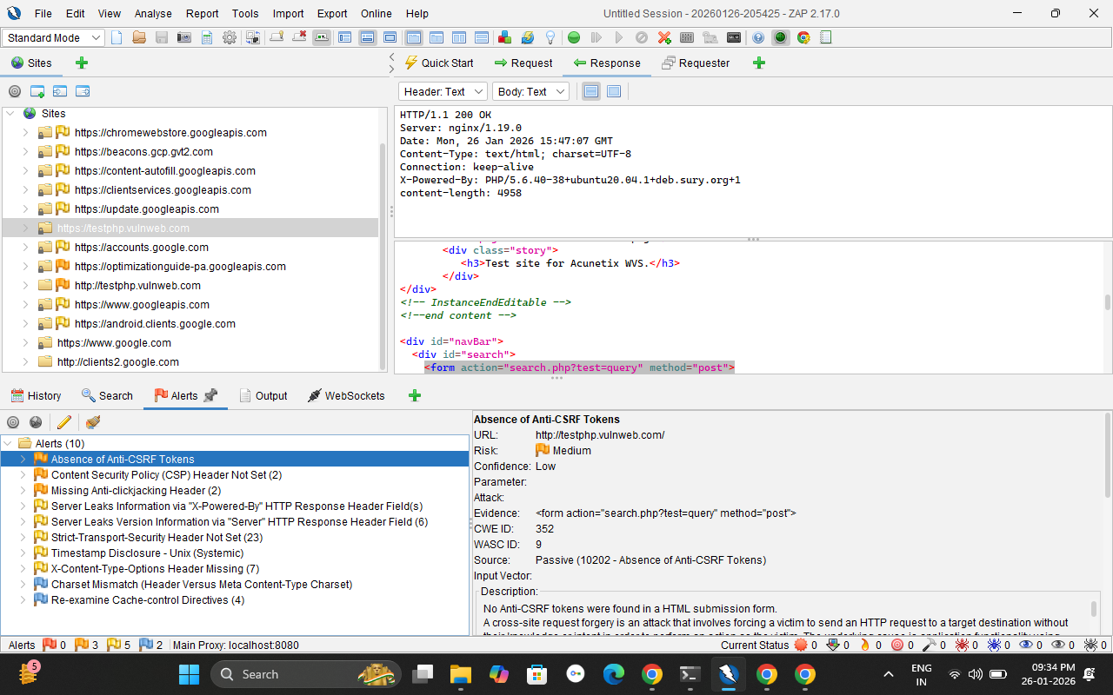

- The server discloses technology details through the X-Powered-By header, which can help attackers identify backend technologies and plan targeted attacks.

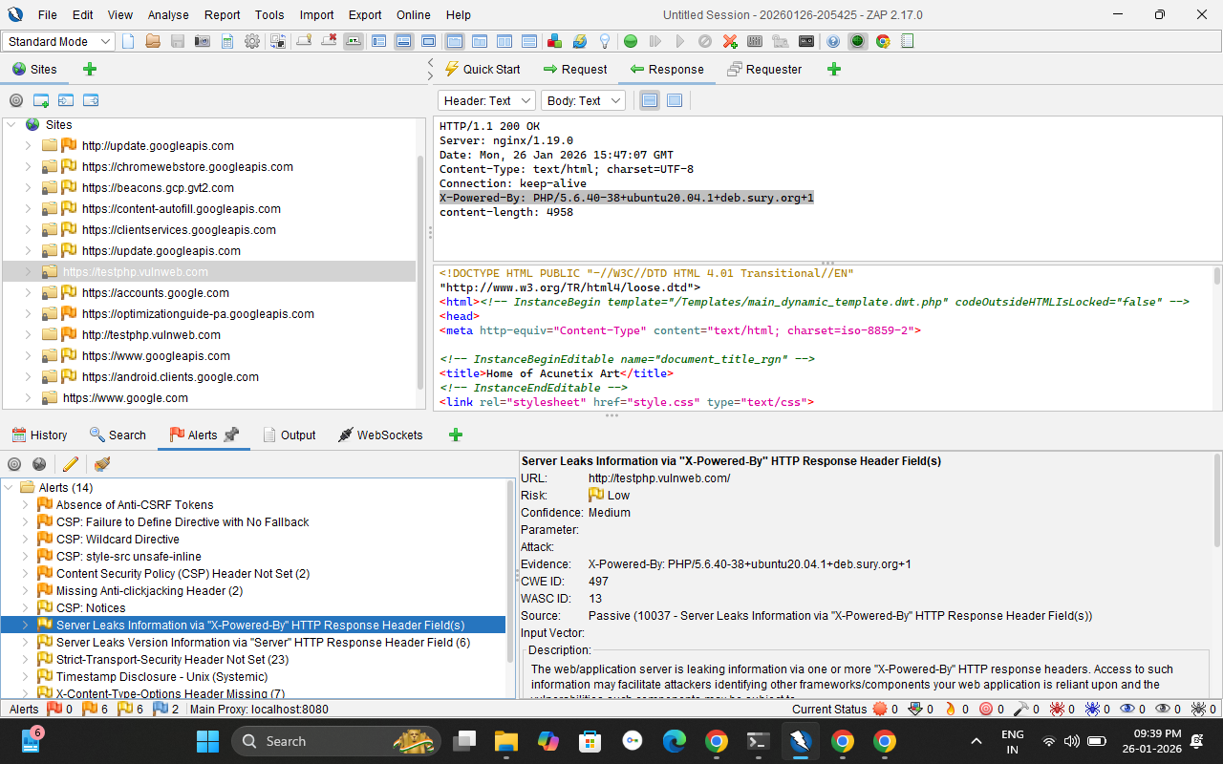

- This alert shows that the X-Frame-Options header is missing, allowing the application to be vulnerable to clickjacking attacks.

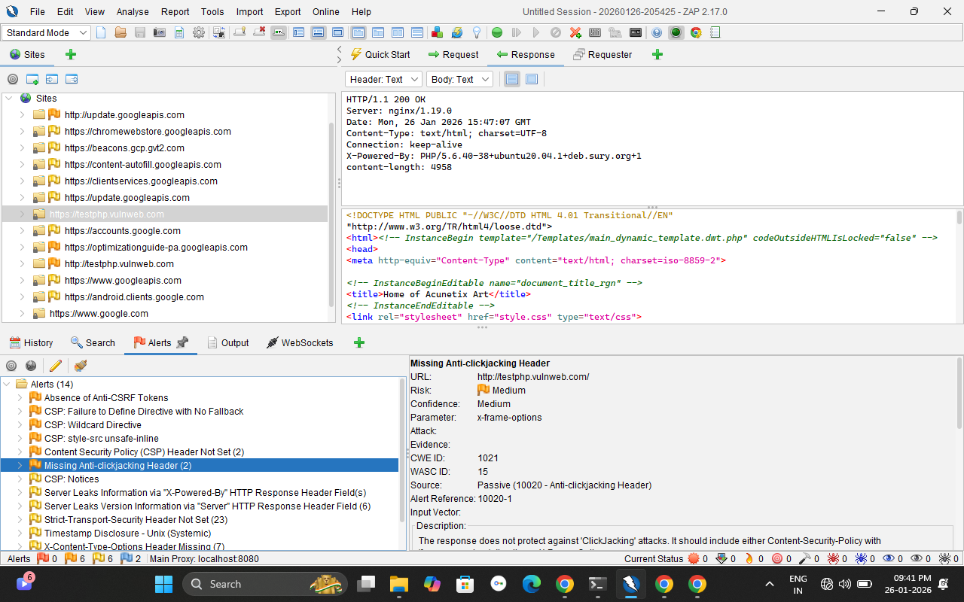

- This alert indicates that the X-Content-Type-Options security header is missing, which may allow MIME-type sniffing by browsers.

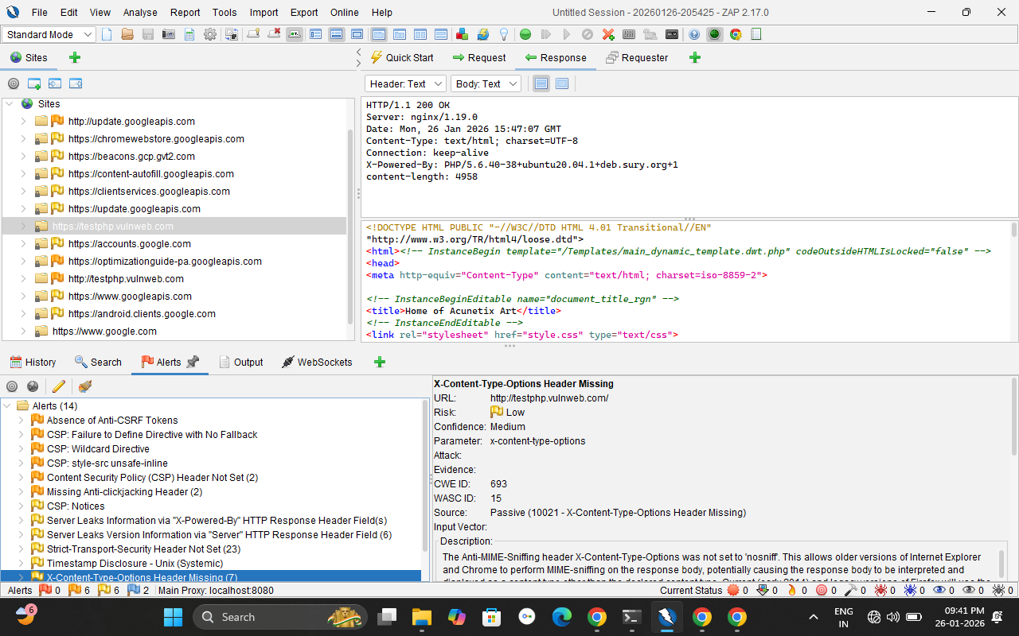

Key Findings

- Live websites often contain common vulnerabilities due to weak validation
- Automated tools combined with manual testing improve detection
- Security misconfigurations are frequent causes of risk
- Awareness of vulnerabilities helps prevent real-world attacks

Limitations

- Assessment limited to an intentionally vulnerable test website
- No aggressive exploitation performed
- Results depend on tool configuration and scope
- Cannot replace a full professional penetration test

Conclusion & Internship Learning Outcomes

This internship half evaluation task provided hands-on experience in assessing a live web application under ethical constraints. The project improved understanding of web vulnerabilities, risk classification, and professional security documentation.
Key learnings include:
- Ethical vulnerability assessment practices
- Identifying OWASP Top 10 vulnerabilities
- Risk-based security analysis
- Writing structured vulnerability assessment reports

Thank you

